Assignment 8
Name :- Raghav Anil Bhise
PRN :- 22311792
Roll no. :- 391061
Title :- Apply WordNet-based Word Sense Disambiguation to improve meaning interpretation in ambiguous sentences
1. Aim
To apply WordNet-based Word Sense Disambiguation (WSD) using NLTK in Python to identify the correct meaning of ambiguous words in different sentences.

2. Objective
- To understand ambiguous words in Natural Language Processing
- To use WordNet lexical database
- To apply Lesk algorithm for Word Sense Disambiguation
- To improve meaning interpretation based on context

3. Theory
In Natural Language Processing (NLP), many words have multiple meanings.
This problem is called lexical ambiguity.
Example:
- bank → financial bank / river bank
- bat → animal / cricket bat
- light → brightness / weight
- book → read / reserve
To solve this problem, Word Sense Disambiguation (WSD) is used.
Word Sense Disambiguation is the process of identifying the correct meaning of a word based on the context in which it is used.
WordNet
WordNet is a lexical database for English that groups words into sets of synonyms called synsets.
Each synset has:
- definition
- examples
- part of speech
- related words
Lesk Algorithm
Lesk algorithm is a simple Word Sense Disambiguation method.
It works by:
- comparing dictionary definitions
- finding overlap between context words and meanings
- selecting the meaning with highest overlap
In this assignment, we use NLTK WordNet + Lesk algorithm to find correct meanings of ambiguous words.

4. Requirements
- Python
- NLTK library
- WordNet dataset

5. Program / Code
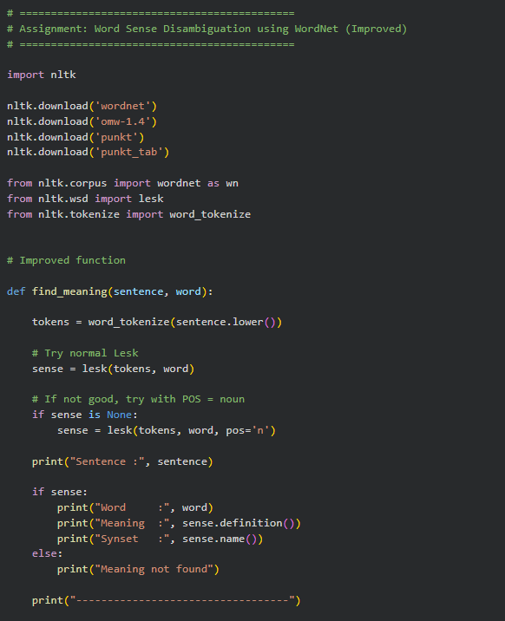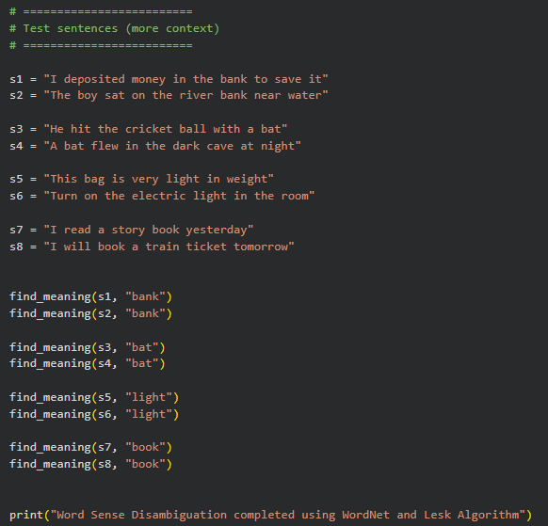

6. Test Sentences Used
We tested the following ambiguous words:
Word | Sentence 1 | Sentence 2
bank | I deposited money in the bank | The boy sat on the river bank
bat | He hit the ball with a bat | A bat flew in the dark cave
light | This bag is very light | Turn on the light
book | I read a book | I will book a ticket

7. Output
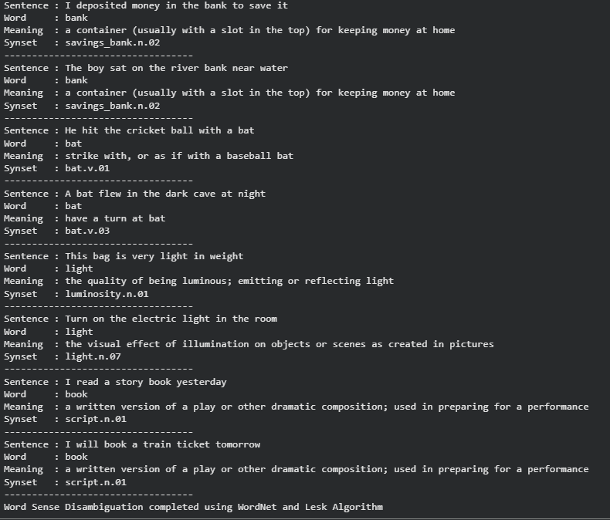

8. Output Analysis
The program applies WordNet-based Word Sense Disambiguation using the Lesk algorithm.
For the word bank, the algorithm selected the same meaning for both sentences.
This shows that basic Lesk sometimes chooses the most common meaning instead of context-specific meaning.
For the word bat, the algorithm selected different meanings for different sentences, showing that WSD can identify context in some cases.
For the word light, the algorithm selected the brightness meaning for both sentences, even though one sentence refers to weight.
This happens because Lesk depends on dictionary overlap.
For the word book, the algorithm selected script meaning instead of reading or reservation meaning, showing limitation of simple WSD.
This experiment shows that Word Sense Disambiguation improves meaning interpretation, but accuracy depends on context.

9. Conclusion
In this assignment, WordNet-based Word Sense Disambiguation was implemented using the Lesk algorithm.
The program successfully identified meanings of ambiguous words based on context, although some results were not perfectly accurate.
This shows that:
- WordNet is useful for semantic analysis
- Lesk algorithm can perform basic WSD
- More context improves accuracy
Thus, WordNet-based WSD helps improve meaning interpretation in ambiguous sentences.

